|  |  |
| --- | --- |
| **Test Name** | Crown & Anchor Automated Test - Fix Bug 2 |
| **Use Case Tested:** | Automate the testing of errors in UAT Test 2 (after fixing Bug 2) |
| **Test Description:** | Test that player cannot reach betting limit |
| **Pre-conditions** | Single player ‘Richard’ created  Game limit is set = 0  Each run to use a single dice value ‘CROWN’ as the player’s pick  Game will play 10 turns |
| **Post-conditions** | n/a |
| **Notes:** | **An assert will determine if player’s balance reaches the zero limit.**  **This test also shows Bug 4, which is that each roll in the same game produces the same three dice rolls.** |
| **Result (Pass/Fail/Warning/Incomplete)** | **1) Player keeps losing and limit reached (exception error displayed that further bet would go beyond limit) and balance = 0. Bug is fixed – see Screenshot 1.**  **2) If player keeps winning until end of game, limit is never reached – see Screenshot 2.** |

# Screenshots for Results (by number of result)

Screenshot 1:

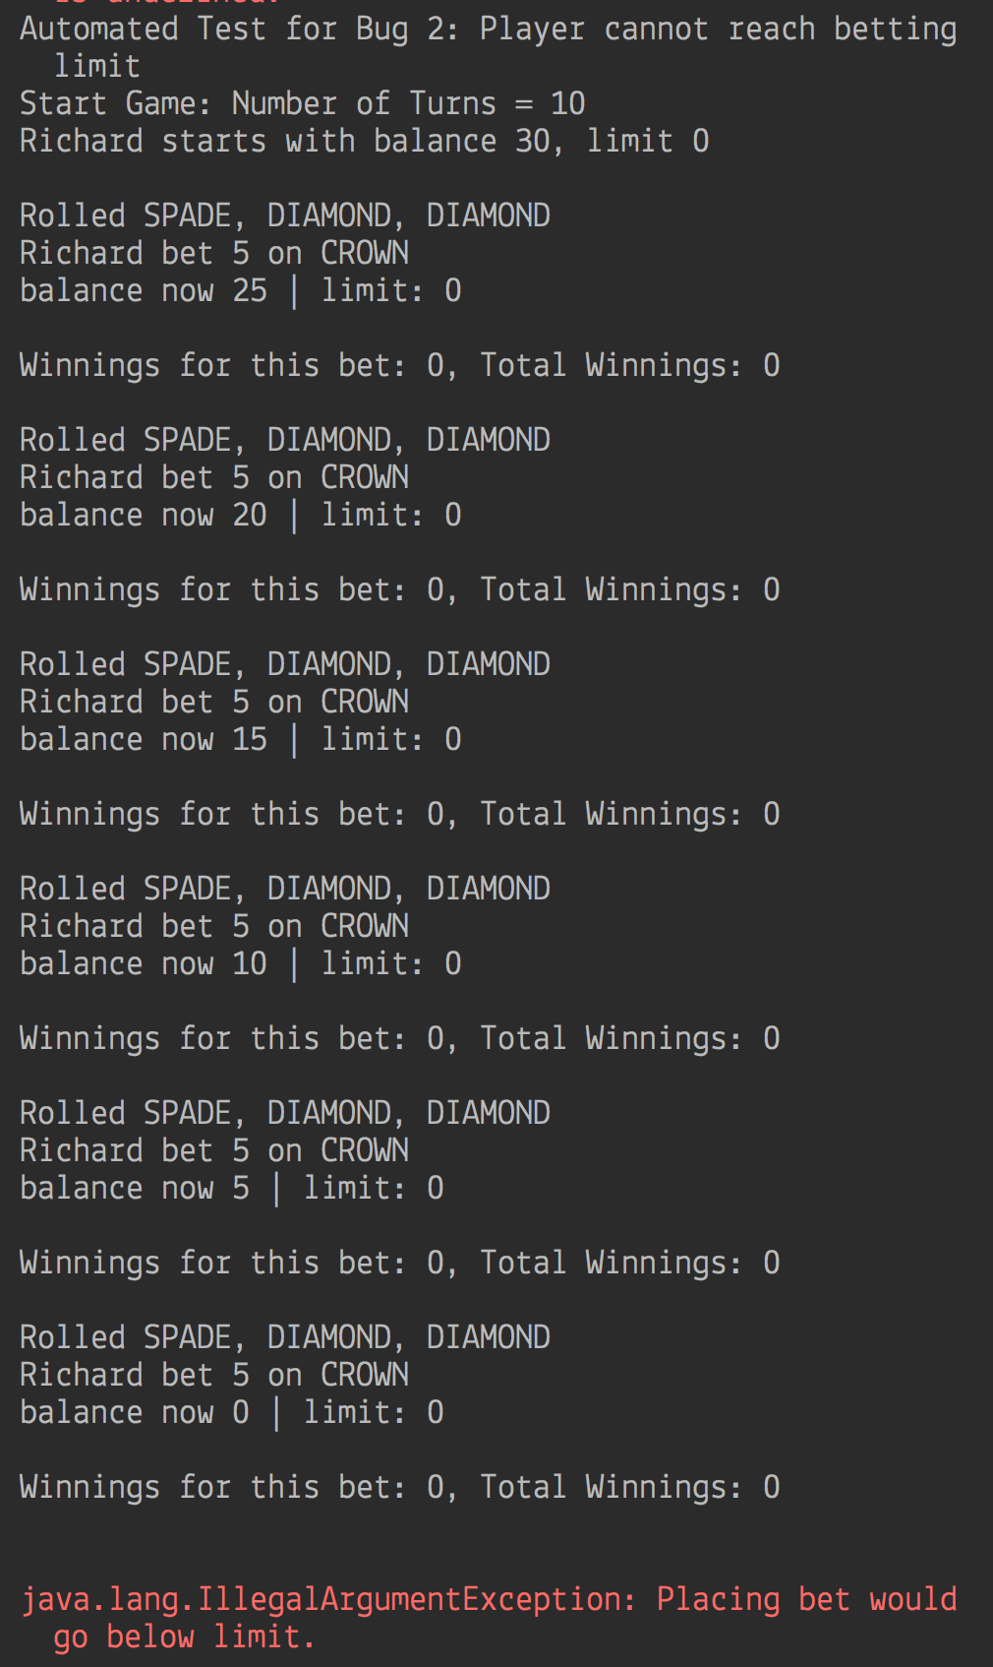

Screenshot 2:

